4.4 Algorithm design

4.4.1 Convolutional Neural Network

Convolutional neural network(CNN) is a specially designed artificial neural network with multiple hidden layers based on the study of cells in the visual cortex of cats by Hub and others. Convolutional layer, pooling layer, and activation function are important components of convolutional neural networks.

CNN reduce the complexity of the network model through three strategies: local receptive fields, weight sharing, and down-sampling. At the same time, it has a degree of invariance to changes in translation, rotation, and scale scaling. Therefore, it is widely used in image classification, target recognition, speech recognition and other fields. In general, common convolutional neural networks are composed of input layer, convolution layer, activation layer, pooling layer, fully connected layer and final output layer.

CNN uses the original image as input, which can effectively learn the corresponding features from a large number of samples, avoiding the complicated feature extraction process. Because CNN can directly process two-dimensional images, it has been widely used in image processing and has achieved more research results. The network extracts more abstract features from the original image through a simple non-linear model, and only a small amount of human involvement is required in the whole process.

Due to the two characteristics of local perception and parameter sharing, local perception, that is, convolutional neural network, proposes that each neuron does not need to perceive all pixels in the image, but only perceives the local pixels of the image, and then combines local information at a higher layer Merging to obtain all the characterization information of the image.

The neural units of different layers are locally connected, that is, the neural units of each layer are only connected to some of the neural units of the previous layer. Each neural unit only responds to the area in the receptive field and does not care about the area outside the receptive field at all. Such a local connection mode ensures that the learned convolution kernel has the strongest response to the input spatial local mode. The weight sharing network structure makes it more similar to a biological neural network, which reduces the complexity of the network model and reduces the number of weights. This kind of network structure is highly invariant to translation, scaling, tilt or other forms of deformation. Moreover, the convolutional neural network uses the original image as input, which can effectively learn the corresponding features from a large number of samples, avoiding the complicated feature extraction process.

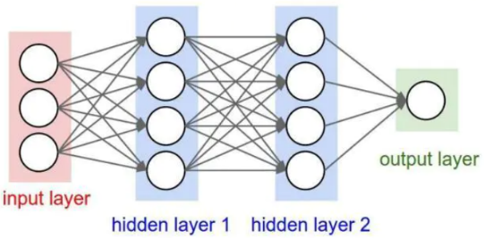

4.4.2 Object detection problem

Object detection, also called object extraction, is a method based on convolutional neural networks, which combines target segmentation and recognition into one. Its accuracy and real-time performance are an important capability of the entire system. Especially in complex scenes, when multiple targets need to be processed in real time, automatic target extraction and recognition is particularly important.

With the development of computer technology and the widespread application of computer vision principles, the use of computer image processing technology to track targets in real-time is becoming more and more popular. Dynamic real-time tracking and positioning of targets are used in intelligent transportation systems, intelligent monitoring systems, and military target detection. And the positioning of surgical instruments in medical navigation surgery has wide application value.

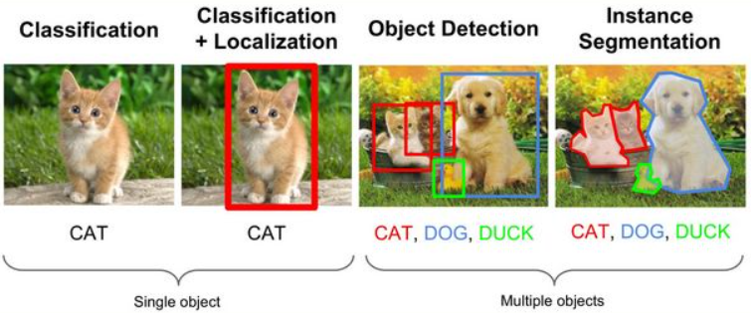

The main algorithms of the target detection problem are fast-RCNN, YOLO, SSD, etc., which are divided into one-stage and two-stage. We use the target detection method to identify each spine with bounding box.

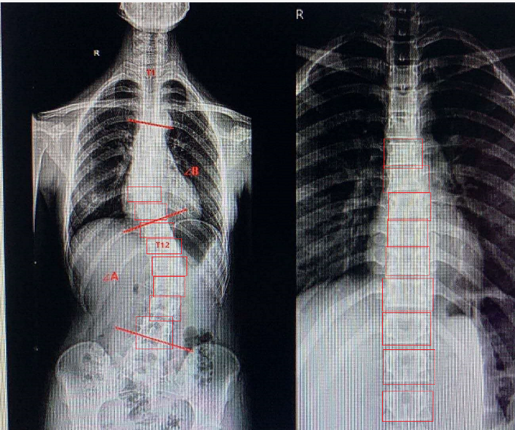

4.4.3 Curve fitting and calculating angle

After target detection, we can get the midpoint coordinates of the vertebrae we need, and use the midpoint coordinates for cubic curve fitting.

The polyfit function is a function used for curve fitting in matlab. Its mathematical basis is the principle of least squares curve fitting. Curve fitting: Knowing the data set on the discrete point, that is, the function value on the point set, construct an analytic function (its graph is a curve) to make the original discrete point as close as possible to the given value.

After obtaining the cubic curve, take 100 points uniformly on the curve, calculate the normal vector of the curve at the shop, calculate the intersection angle of the normal vector two by one, and take the maximum angle value as the final result.

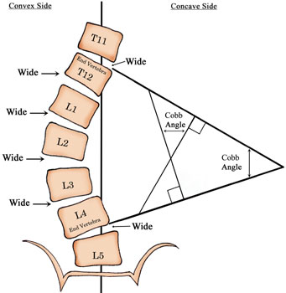

4.4.4 Lenke Classicacation

Lenke classification is a comprehensive radiographic classification of Adolescent Idiopathic Scoliosis named after Dr Lawrence Lenke who was instrumental in devising it.For classification, the following things are used.

* By the curve type
* Lumbar spine modifier
* Sagittal thoracic modifier.

The Lenke Classification System recognizes and measures scoliosis as a multi-dimensional problem. It thus helps to devise a focused treatment. The Lenke classification is a triad classification system consisting of:

1.curve type (1-6)

2.lumbar spine modifier (A, B, C)

3.sagittal thoracic modifier (-, N, +)

**Step 1 – Determination of curve type**

The spine is divided into 3 regions: Proximal thoracic – Apex at T3, T4 or T5. Main thoracic – Apex between T6 and the T11-T12 disc. Thoracolumbar/Lumbar – Thoracolumbar apex between T12 and L1, and lumbar apex between the L1-L2 disc and L4

Proceed as follows. Measure regional curves. Proximal thoracic (PT). Main thoracic (MT). Thoracolumbar/lumbar (TL/L)

Determine if a minor curve is structural or not. This is done by evaluating the left and right supine bending and lateral x-rays. Following criteria are used for marking the curves structural. Only one of the two criteria needs to be met.

Minor Proximal thoracic: Residual coronal curve greater than or equal to 25 ° on supine bending radiograph. Kyphosis T2 – T5 of greater than or equal to 20 °

Minor main thoracic curve: Residual coronal curve greater than or equal to 25 ° on supine bending radiograph. Kyphosis T10 – L2 greater than or equal to 20 ° (regardless of coronal flexibility)

Minor thoracolumbar/lumbar curve: Residual coronal curve greater than or equal to 25 ° on supine bending radiograph. Kyphosis T10 – L2 greater than or equal to 20 ° (regardless of coronal flexibility)

Assign Type 1-6 based on the chart below.

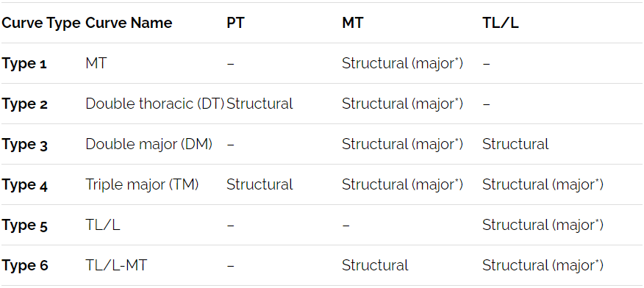

**Step 2 – Assignment of Lumbar modifiers (A,B,C)**

Identify apical lumbar vertebrae (ALV). Inferior lumbar body that falls outside of the curve

Draw vertical line from the center of the sacrum. See its relationship to pedicles of apical lumbar vertebra.

Assign modifier. A-CSVL passes between pedicles of apical lumbar vertebrae. B-CSVL touches pedicle of apical lumbar vertebrae. C-CSVL does not touch apical lumbar vertebrae.

**Step 3: Assignment of Sagittal thoracic modifier (-, N, +)**

Measure sagital Cobb from T5 to T12. Assign modifier. hypokyphotic (-) if < 10°. normal if 10-40°. hyperkyphotic (+) if >40°.

Combine the three values to provide final triad.